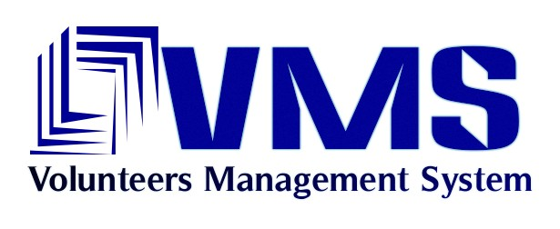

Volunteers’ Management System
User Manual for Volunteers

By:
Apollo Group

Table of Contents

Content Page #

Table of Contents 2
1. Introduction 3
2. VMS Background 4
3. Constraints 5
4. How To: 6
4.1 Registration of a volunteer 6
4.2 Login to the profile 6
4.3 Volunteers Edit and Delete profile 7
4.4 Volunteers Login to the VMS system 8
4.5 Reporting new Incident 9
4.6 Answer Request 10
4.7 Reporting the progress of the incident 10
4.8 Getting alert messages 11
5. VMS Mobile application installation guidelines 12
6. Trouble Shooting 13
6.1 Forgot username/password 13
6.2 Other problems 13
7. Glossary 14
8. Revision History 15

Introduction

This document aims at giving an overview of the VMS from a volunteer’s prospective. It describes the system functionalities and how to achieve them with step by step process. This document is mainly produced for purpose of creating common understanding about the VMS among the different volunteers and to guide them in achieving the intended tasks.

VMS Background
VMS can be viewed as 2 separate parts, one is VMS Mobile/Client Application and the other is VMS Portal Application. The VMS Mobile application is developed for Volunteers. This application has to be installed to the volunteer’s mobile phones for active participation during the major crisis (For installation instructions refer to section 5, VMS Mobile application installation guidelines).
By this application any citizens can be involved in resolving incidents and crisis by rendering their services or by contributing their useful stuffs during the crisis. This is a combined effort between help organizations and the regular citizens. Help organizations will coordinate the volunteers to address the crisis issues.
Crisis organization’s coordination will be handled by the VMS portal application which includes sending request to volunteers, sending alerts and so on. These things will be controlled and coordinated by the managers of the help organization with the help of VMS.
Volunteer’s operations will be handled by the VMS Mobile application, which allows the volunteers to send the new incident report, to report the progress status of the requests, to support the crisis by serving the needs or the services to the people affected by crisis.

Constraints
Some of the prerequisites for using VMS Mobile application are
- Citizens should have mobile phones with Java support to use the VMS Mobile application.
- Internet access is needed to get the application from the website and install it into the mobile phone.
- Internet access from the mobile phone is needed to use VMS Mobile application.

How To:
This section explains how to use the VMS Mobile application in steps.

Registration of a volunteer
Before using the VMS Mobile application, the volunteers must be registered. For registration

- Go to login page of the website http://licrp.dnsalias.net/apollo/login.aspx (Figure 1.)
- Select ‘Volunteer’ from the dropdown box
- Click ‘Register’ button. Volunteer’s registration page will be opened.
- Fill :
First and Last Name-> Birth Date-> Gender->Phone->Height->Weight->Health problems->Educations & Training->Occupation-> Country->City-> Street-> House No-> Flat No-> Postal code-> Email address-> Username-> Password
- Click ‘Register’ button.

The error messages will be displayed for some of the field values validation.

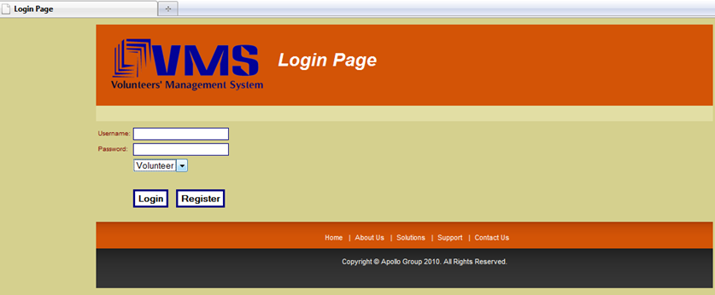
Figure1. VMS portal’s Login page

Login to the profile
Volunteers can login to the VMS Portal application to edit/delete their user profile. For logging to the VMS portal application the user must be a registered user. For logging in
- Go to login page of the website http://licrp.dnsalias.net/apollo/login.aspx (Figure 1.)
- Type valid Username and Password
- Select ‘Volunteer’ from the dropdown box
- Click ‘Login’ button
User will be navigated to the profile’s page.

The error message will be displayed for incorrect user name or password.

Volunteers Edit and Delete profile

Registered volunteers can change the registration information. For editing the volunteer’s information

- Login to the profile from http://licrp.dnsalias.net/apollo/login.aspx
- Fill the new values to the fields which requires modification
- Click ‘Update’ button

An error message will be displayed for any field value modification rules violation. All the fields are editable except username field.

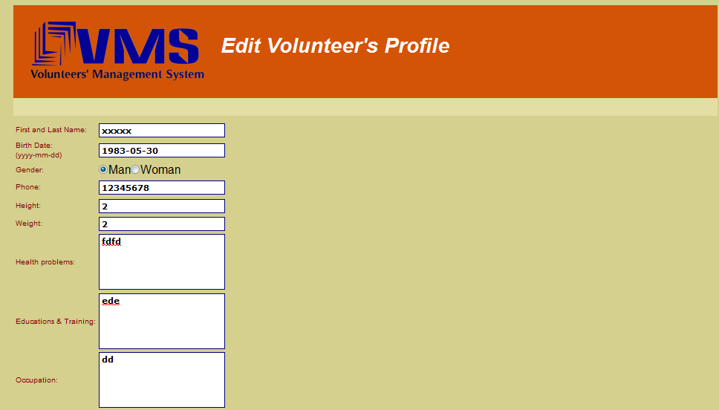
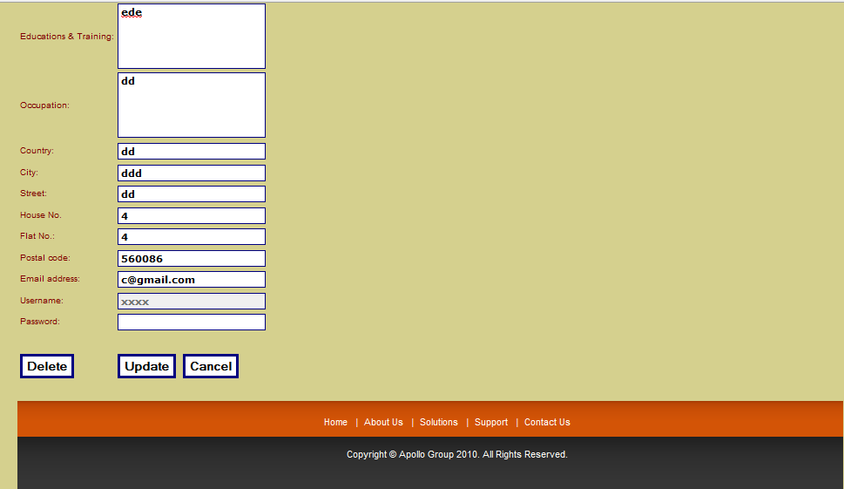
Figure 2. Volunteer’s profile page.

Any volunteer can delete their profile from the VMS. If a user’s profile is deleted from the system than the user will not be able to use the VMS Mobile application. For deleting volunteers profile

- Login to the profile from http://licrp.dnsalias.net/apollo/login.aspx
- Click ‘Delete’ button (Figure 2)
- Select ‘Yes’ for conforming the deletion (Figure 3)
- Click ‘Apply’ button.

The volunteers profile will be deleted from the VMS.
If the user decides to keep the profile after pressing ‘Delete’ button then he/she can retained the profile by selecting ‘No’ in conformation.


Figure 3. Confirmation of deletion of the profile.

Volunteers Login to the VMS system
Volunteers can login to the VMS system is needed to use the VMS Mobile application. For logging in

- Launch the application.
- Type the valid ‘Username’ and ‘Password’
- Click ‘Login’ button

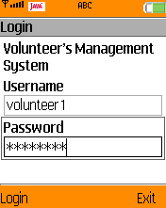
Figure 4. VMS Mobile application’s login page.

After successful login the main page will be displayed (Figure 5).

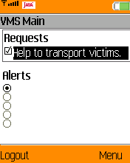
Figure 5. VMS Mobile application’s main page.

The error message will be displayed for incorrect user name or password.

Reporting new Incident
Volunteer can inform the organization about an incident by reporting it via VMS Mobile application. This option is available to the volunteers to get immediate report about the new crisis in the society. Volunteers can send some information such as type of the incident, location and related message to the help organization. For reporting new incident

- Login to the Mobile application.
- Go to Report incident page from the main page Menu->Report incident.
- Type Location of the incident-> choose Incident type-> type Message to the Manger
- Go to ‘Menu’ and select ‘Send’ option.

The incident report message will be sent to the help organization to take necessary action. If you decide to cancel the message sending in the before sending then go to Menu->Exit, the message sending will be discarded.

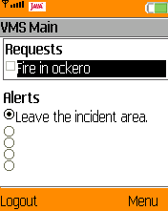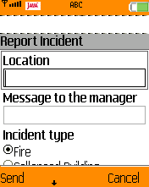
Figure 6. Reporting new incident.

Answer Request
The request sent by the Help organization can be answered by the volunteers by replying to it. As soon as the volunteers logs into the VMS Mobile application the new request to the Volunteers will be shown in the main page. For responding

- Login to the VMS Mobile application.
- Select the Request from the main page by checking the checkbox against the request.
- Select Menu->Open
- Fill the need list which you can give to the crisis effected people.
- Select ‘Accept’ button.

The answer will be sent to help organization.
If the volunteers want to reject the request, select ‘Reject’ button.

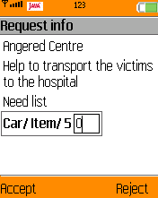
Figure 7. Answering to the manager’s request.

Reporting the progress of the incident
If the volunteers have accepted a request, then they can send the progress of the request related incident to help organization. For reporting the incident progress

- Login to the Mobile application.
- Select Menu->Progress Report.
- Choose the status of the incident from the list.
- Type message to the help organization indicating the incident progress
- Select ‘Send’ button.

The progress report will be sent to the help organization. If you decide to cancel the progress message sending before sending it then select ‘Cancel’ button. The progress message sending will be discarded.
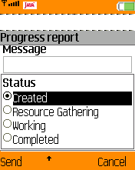
Figure 8. Reporting the progress of incident resolutions.

Getting alert messages
In case of possible danger for the Volunteers in the particular area or location, crisis manager can inform the Volunteers in that area by sending them an alert. For getting alert message

- Login to the VMS Mobile application.
- Select the Alert from the main page by checking the checkbox against the request.
- Select Menu->Open
- Alert message will be displayed on the screen.
- Select ‘OK’ button.

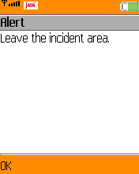
Figure 9. Opening alert message.

After Opening the alert the alert notification will disappear for the main screen.
Volunteers cannot get more than five alerts at the same time.

VMS Mobile application installation guidelines

Before using the VMS Mobile application volunteers need to install it.

- To get the application direct from the mobile phone go to http://licrp.dnsalias.net/apollo/login.aspx site using the mobile phone’s web browser, select VMS Mobile application link and download the application into your mobile phone.
- To get the application direct from the computer go to http://licrp.dnsalias.net/apollo/login.aspx site using the web browser, select VMS Mobile application link and download the application into your computer. Connect your mobile phone to the computer and upload the application into your mobile phone.

Install the mobile application on your mobile phone.

Trouble Shooting
This section contains instructions for fixing the problem VMS Mobile application.

Forgot username/password
In case of forgotten username and/or password the new profile needs to be created. It is not possible to retrieve the forgotten username/password.

Other problems
Contact vmssupportteam@gmail.com for any problems with VMS Mobile application.

Glossary
- NGO’s/Help Organization: Legally constituted, non-governmental organization created by natural or legal persons with no participation or representation of any government. In the cases in which NGOs are funded totally or partially by governments, the NGO maintains its non-governmental status and excludes government representatives from membership in the organization.
Ex:-RED CROSS, Amnesty International, Civil Defense.
- Citizen Volunteer: People working on behalf of others without being motivated by financial or material gain. Volunteering generally considered an altruistic activity, intended to promote good or improve human quality of life.
- Community: A community is a group of interacting organisms sharing an environment. In human communities, intent, belief, resources, preferences, needs, risks, and a number of other conditions may be present and common, affecting the identity of the participants and their degree of cohesiveness.
- User: Anyone uses the VMS system. Covers crisis manager and volunteers.
- Crisis: Crisis is unexpected and non-routine events or series of events that can cause trouble to the human beings normal day to day life.
- Crisis Management: The process by which an organization deals with a major unpredictable event that threatens to harm the organization, its stakeholders, or the general public.
- Volunteer’s Management System : VMS

Revision History

Name | Date | Reason for Changes | Version
Shobha BC | 4 May 10 | Created the User manual with all the section | 1.0
Mustafa Al-Zubaidi  Tigran Harutyunyan | 5 May 10 | Review | 1.1
Shobha BC | 6 May 10 | Reflected the comments | 1.2
Tigran Harutyunyan | 12 May 10 | Added section 5 and 6. Corrected section 3 and 4 | 1.3
Tigran Harutyunyan | 15 May 10 | Applied Magnus’s feedback | 1.4
Tigran Hartyunyan  Shobha BC  Waseem Soomro | 18 May 10 | Review and fix of the document. | 1.5
Waseem Soomro | 19 May 10 | Screen images updated | 1.6

